Making It Work Gender and Disability project

Project Brief July 2023

The Making It Work (MIW) initiative, conceived in 2014 to support the effective implementation of the Convention on the Rights of Persons with Disabilities (CRPD), very quickly focused on highlighting and supporting actions led by organisations run by disabled women; becoming the Making It Work Gender and Disability project.
Recognising the lack of attention paid to the discrimination and violence suffered by women with disabilities, MIW has since documented 26 good practices in 10 countries aimed at preventing and responding to violence and, more broadly, promoting the rights of women and girls with disabilities.

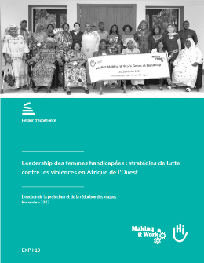
Since 2021, MIW has expanded its network in West Africa with new partners in Benin, Senegal and most recently Togo. Find out more about them in MIW's 2022 report "Leadership of women with disabilities: strategies to combat violence in West Africa".
Today, MIW has a network of 17 partner organizations in 10 countries on the African continent: Benin, Burundi, Cameroon, Kenya, Malawi, Nigeria, Rwanda, Senegal, Togo and Uganda.

Promoting the leadership and rights of women with disabilities

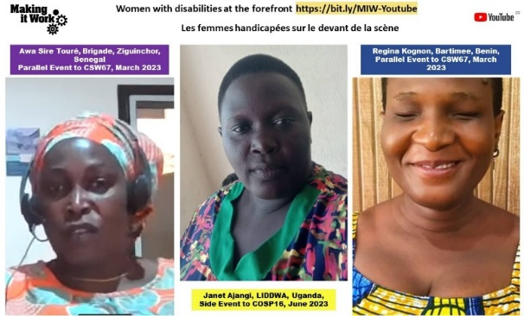

The MIW team and the partner organizations are working together to: 1) contribute to lifting the invisibility of women and girls who are victims of multiple and intersectional discrimination through evidence-based advocacy led by the organizations’ women leaders 2) increase the impact of the actions of women-led organizations, in particular through the scaling-up, with MIW's financial and technical support, of their good practice in preventing and responding to violence against women and girls with disabilities.

- Read the contribution of 14 organizations on the equal and inclusive representation of women in decision-making systems for the CEDAW Committee, February 2023 at this link
- Listen to 3 women leaders with disabilities panelists in 2023 at the Commission on the Status of Women CSW67 and the Conference of States Parties to the International Convention on the Rights of Persons with Disabilities COSP16 on our Youtube channel

MIW: intersectionality in practice
Drawing on the experience of the partner organizations that are members of this unique network, MIW has become increasingly involved in efforts to advance the full realization of the rights of women and girls suffering from multiple and intersectional discrimination.

Strengthening its expertise with its partner associations, MIW has co-developed with Inclusive Friends Association Nigeria the "Practical Guide: Intersectionality in Action" , published in May 2022.
This guide provides steps and tools for adopting an intersectional approach to designing and launching projects that will leave no woman behind. It can be used to address, in a given context, the relevant factors of discrimination in order to analyze the experiences of people, whatever their gender, disability, origin, ethnicity, etc.
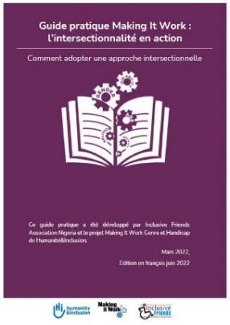

For an anti-ableist, decolonial, anti-racist intersectional feminism
Making It Work takes an intersectional feminist, anti-ableist, anti-racist and decolonial approach to the fight against violence against women and girls with disabilities. This involves addressing gender inequalities as well as ableist stereotypes as root causes of violence against women and girls with disabilities. As well it requires rethinking the working practices and partnership relations between MIW and the women-led organizations based in the global South, in order to achieve an egalitarian partnership approach.

 | Email: s.pecourt@hi.org  Web: makingitwork.hi.org  Facebook: @MakingItWorkCRPD  LinkedIn: www.linkedin.com/company/makingitwork-gender-disability  Youtube: https://bit.ly/MIW-Youtube | 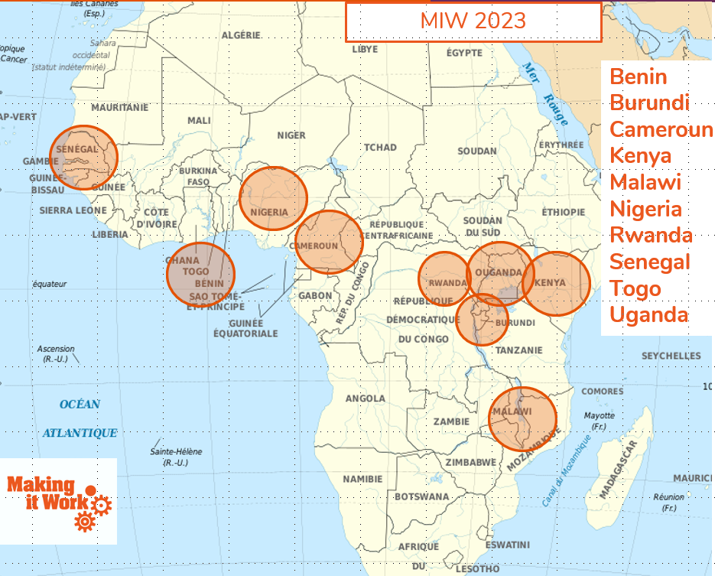

https://www.makingitwork-crpd.org/fr/miw-guide-pratique-lintersectionnalite-en-action

