Making it Work “Gender and Disability” Project: contributing to a world free from violence for Women and Girls with disabilities

Project Brief – August 2018

Remembering Florence Adong-Ewoo, LIDDWA Uganda
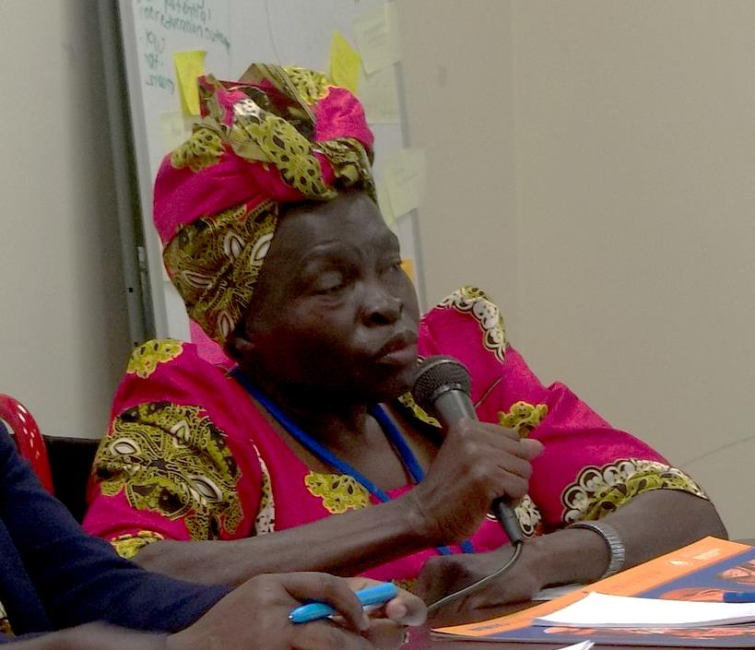
Florence was the Chairperson of Lira District Disabled Women Association, Uganda. She passed away in July at the age of 57, after a road accident. Florence was a natural leader, an activist, a wonderful person, a strong woman, a voice for grassroots women and girls with disabilities. Each of her interventions was a statement, meaningful, reminding the audience that leadership, participation, inclusion and rights of grassroots women are not an option. We want to remember her alive and strong. The Making It Work family is deeply touched. Our heart is full of sadness.
Watch Florence talking about her work on Making It Work-CRPD Youtube channel www.youtube.com/watch?v=eoPV8qCT6VY

Latest news
MIW Gender and Disability Report launched in June 2018  Titled Gender and disability intersectionality in practice: Women and girls with disabilities addressing discrimination and violence in Africa, the report highlights the 9 good practices implemented by our country-partners in Cameroon, Kenya, Malawi, Nigeria, Rwanda and Uganda. | 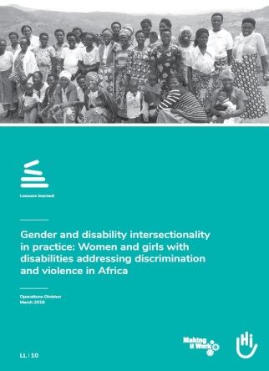
COSP11, June 2018, New York: Side Event dedicated to Intersectionality
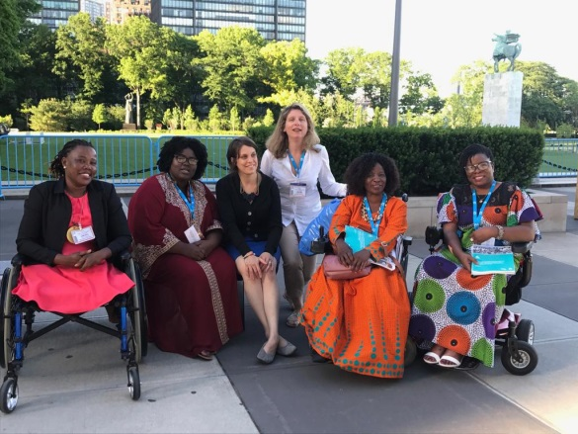
Great success with 50+ people at the Humanity & Inclusion/MIW and Disability Rights Fund Side event on Intersectionality of Gender and Disability. Strong women delivering powerful messages, on women with disabilities empowerment, ensuring full participation and decision making positions for them, etc. Panelists from Disabled Women in Africa – DIWA, Inclusive Friends Association Nigeria, First Peoples Disability Network, Indonesia Mental Health Association and Association des Femmes Handicapées du Sud (Haiti), UN Women East and Southern Africa and representatives from DFID, Government of Canada and DFAT with the support of International Disability Alliance, the African Disability Forum and Syracuse University College of Law.
MIW country partner Jane Kihungi at European Development Days  Jane Kihungi, Executive Director of Women Challenged to Challenge Kenya was a panelist at the EDDs, June 2018, together with Jean de Wetter and Maximilien Zimmermann (HI), Belgian Minister De Croo, a representative from MSF and singer and activist Axelle Red. |  | 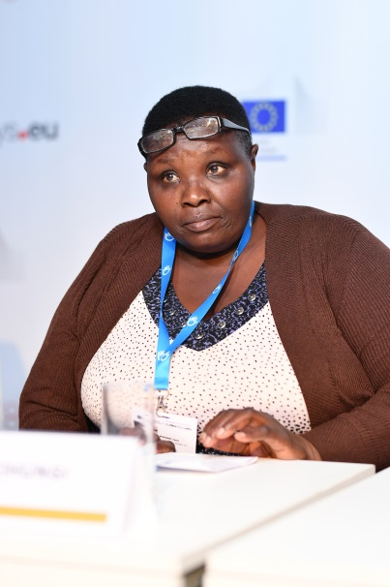  ©EDDs2018

Email: s.pecourt@hi.org ; mc.garin@hi.org
Website: makingitwork.hi.org Twitter: @MIW_CRPD / www.facebook.com/MakingItWorkCRPD/
LinkedIn: www.linkedin.com/company/18451952

